EAST WEST INSTITUTE OF TECHNOLOGY

SRI RAVIKIRAN CENTER OF EXCELLENCE PROGRAM

# DATA SCIENCE USING PYTHON PROGRAMMING

**Department of Artificial Intelligence and Machine Learning**

**3rd Semester**

**(NAAC ACCREDITED, AFFILIATED TO VTU, BELGAVI AND RECOGNIZED BY THE AICTE, NEW DELHI)**

**2024-25**

**Project Name:** Credit card fraud detection

**Mentor Name: Mr Srinivas**

**Presented By:**

**1.Binutha B M[1EW23AI012]**

**2.L Rakshitha[1EW23AI025]**

**3.Moulya K R[1EW23AI030]**

**4.Divyasri S[1EW23AI014]**

**5.Namitha N R[1EW23AI032]**

**Abstract:**

In this paper, we present a comprehensive review of various methods used to detect credit card fraud. These methodologies include Hidden Markov Model, Decision Trees, Logistic Regression, Support Vector Machines (SVM), Genetic algorithm, Neural Networks, Random Forests, Bayesian Belief Network.

**Introduction:**

In the digital age, credit card transactions have become integral to our daily lives. However, this convenience comes with the risk of fraud, which poses significant challenges to financial institutions and consumers. Detecting credit card fraud is crucial to protecting customers and maintaining trust in the banking system. In this article, we will introduce the basics of credit card fraud detection using Python, exploring key concepts, techniques, and practical examples.

**What is Credit card fraud detection?**

Credit card fraud detection encompasses a range of strategies and technologies aimed at preventing unauthorized purchases, whether online or in physical stores. The primary goal is to verify the cardholder’s identity and ensure the legitimacy of each transaction.

**Credit card prevention and detection:**

**Businesses can employ various tactics to prevent, detect, and respond to credit card fraud effectively. These measures can mitigate the risk of fraud and minimise financial losses. Here’s what you need to know about creating a comprehensive plan for fraud detection and prevention and the specific components that it should include:**

* **Secure payment processing  
  Implementing secure payment processing systems, such as those that use tokenisation and encryption, can protect sensitive credit card data during transactions and reduce the risk of breaches.**
* **EMV chip card technology  
  Encouraging the use of**[**EMV chip cards**](https://stripe.com/in/resources/more/what-are-emv-chip-cards)**and adopting EMV-compliant payment terminals can reduce the risk of fraud at brick-and-mortar locations, as chip cards are more difficult to counterfeit than magnetic stripe cards.**
* **Address verification system (AVS) and card verification value (CVV) checks  
  Using**[**AVS**](https://stripe.com/in/resources/more/what-is-address-verification-service)**and**[**CVV**](https://stripe.com/in/resources/more/what-is-card-verification-value)**checks can verify the authenticity of card-not-present transactions and minimise the risk of fraud.**
* **Fraud detection tools  
  Employing fraud detection tools – especially those that use**[**machine-learning**](https://stripe.com/in/resources/more/how-machine-learning-works-for-payment-fraud-detection-and-prevention)**algorithms and behavioural analysis – can flag suspicious transactions before they are processed.**
* **Employee training  
  Educating employees to recognise and prevent fraud can minimise the risk of fraudulent activity, especially in retail environments.**
* **Regular monitoring  
  Monitoring transactions and customer accounts on a regular basis can help businesses identify unusual patterns and catch potential fraud early.**
* **Chargeback management  
  Implementing a chargeback management system can help businesses track, analyse, and respond effectively to**[**chargebacks**](https://stripe.com/in/resources/more/chargebacks-101)**– which can be an indicator of fraud.**

**Code and output:**

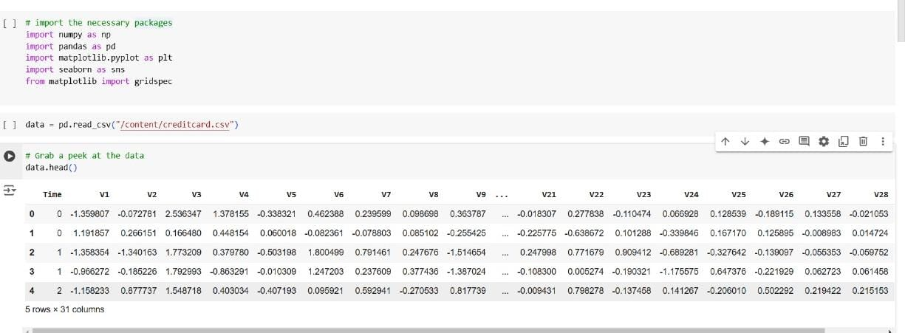

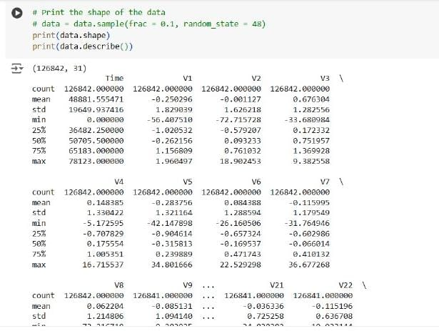

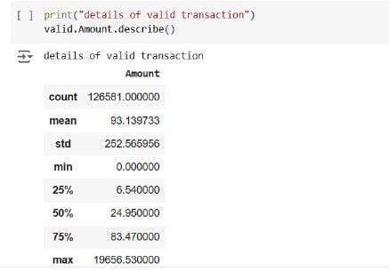

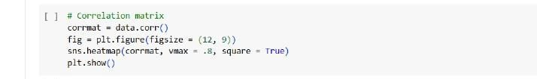

Graph:

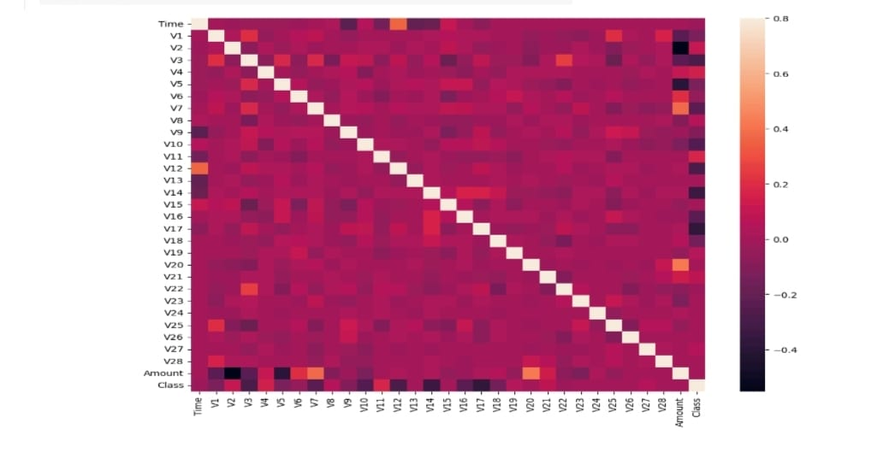

**Conclusion**:

Credit card fraud detection is a set of methods and techniques designed to block fraudulent purchases, both online and in-store. This is done by ensuring that you are dealing with the right cardholder and that the purchase is legitimate.

Thank you